* **SNS Theory**
* SNS is a fast,flexible,fully managed push notification service.
* It is a web service that co-ordinates and manages the delivery or sending of messages to subscribing endpoints or clients.
* It allows for sending individual messages or fan-out messages to a large number of recipients or to other distributed AWS service.
* Message published to an SNS topics will be delivered to the subscriber immediately.
* Inexpensive,pay as you go model with no upfront cost.
* Reliable: At least three copies of the data are stored across multiple AZ in same region.
* It is a way of sending messages.When we are using autoscaling,it triggers an SNS service which will email us that ‘our EC2 instance is growing’

**1. Simple notification service.**

1. **i** to create a topics “COVID-19-WARNING”

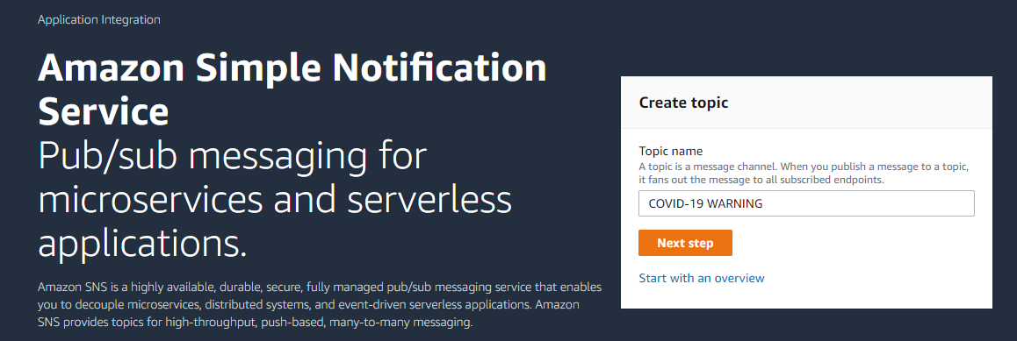

1. I selected standard

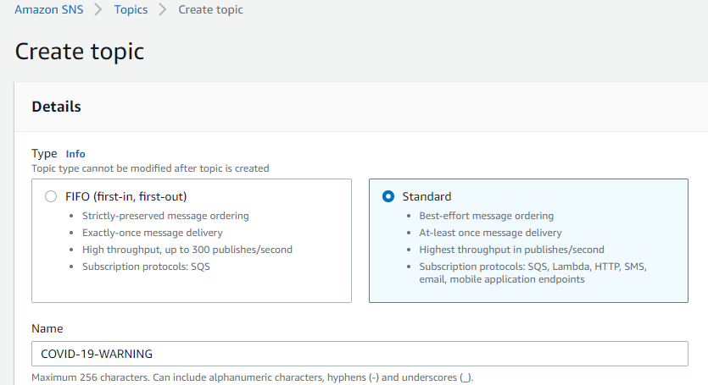



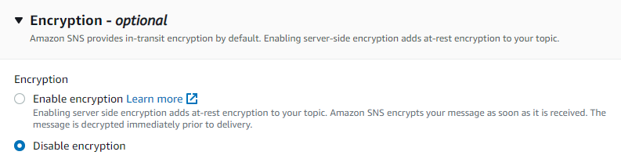



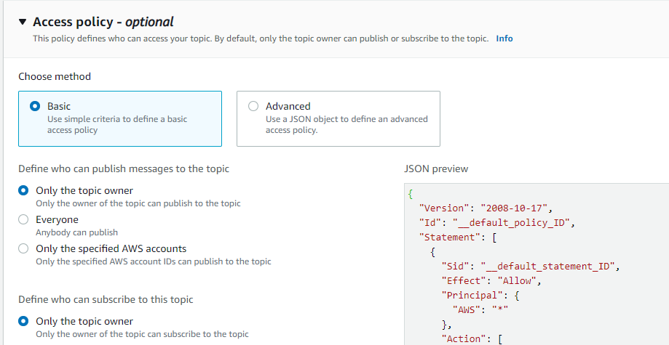



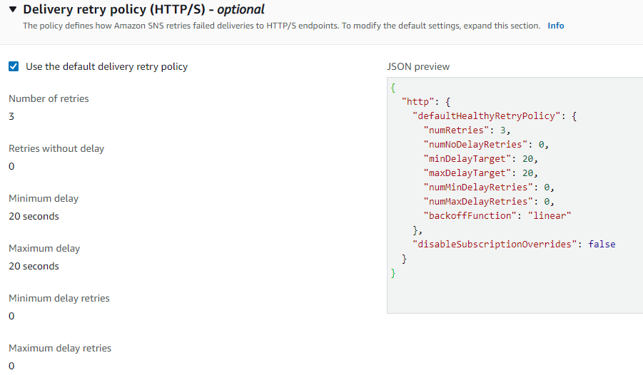

1. Here i created a IAM role and allow permission to access the simple notification service.

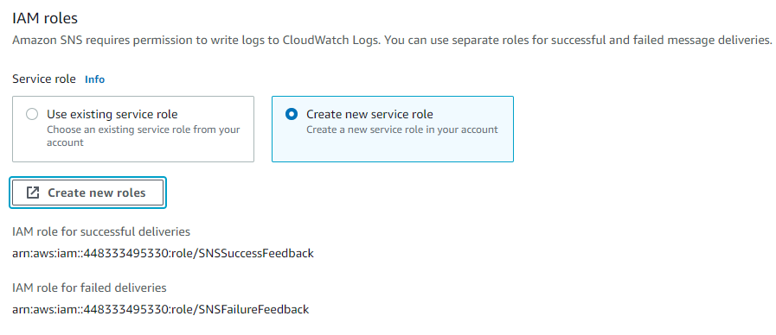

1. Now i have to create a subcription.



1. ARN name . and i choose email type.

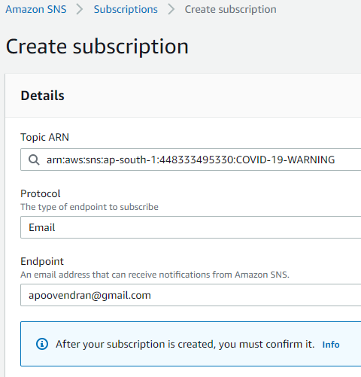



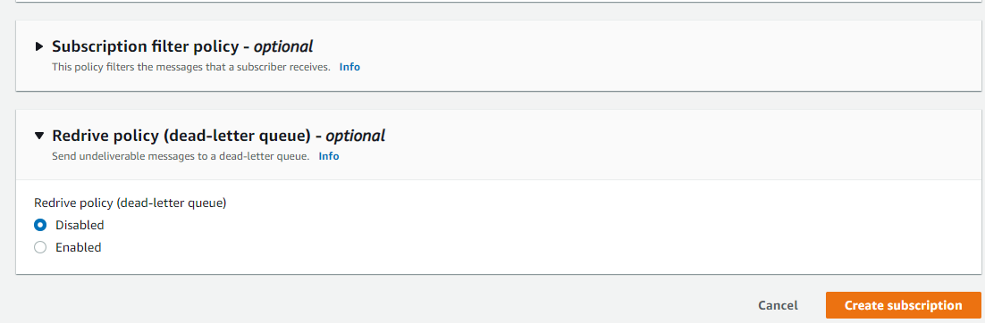



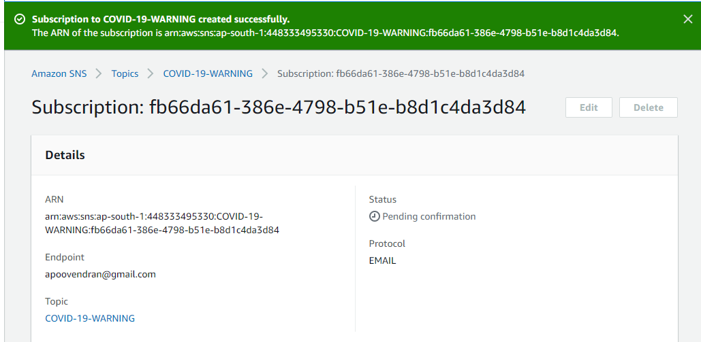



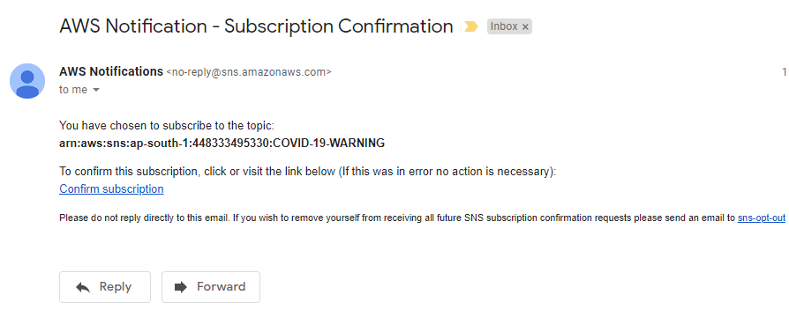

1. Successfully created subscription its status show confirmed .

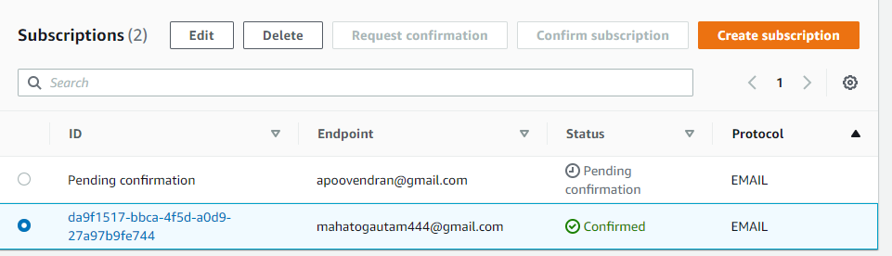





1. Time to live is optional i leave it to further configuration.

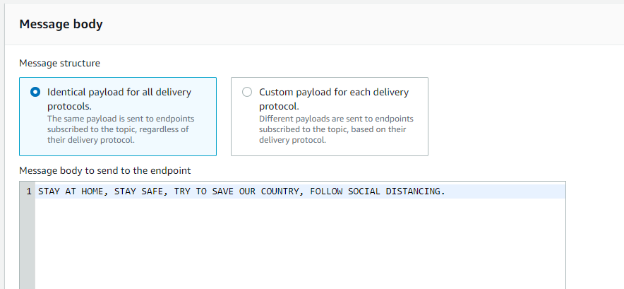

1. It got the covid warning notification.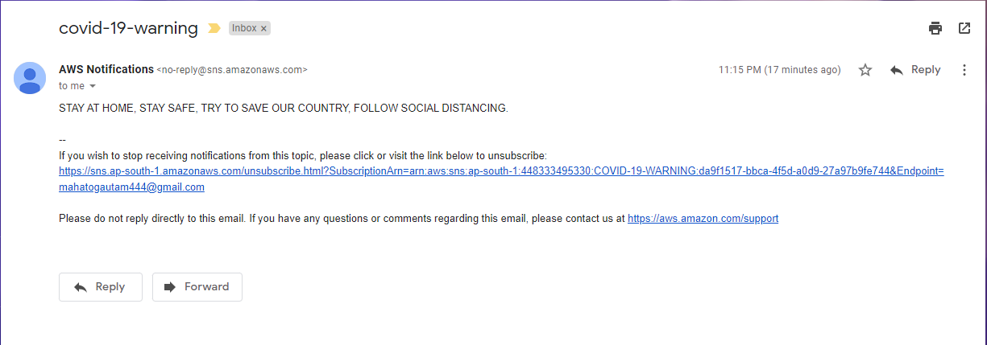

**1.1 mobile type.**



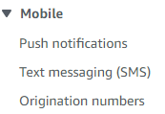



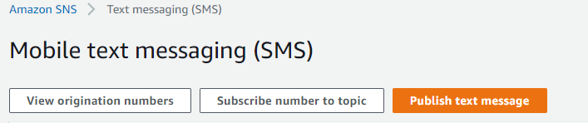

1. First of all add the number and then put it with country code and type sms .

